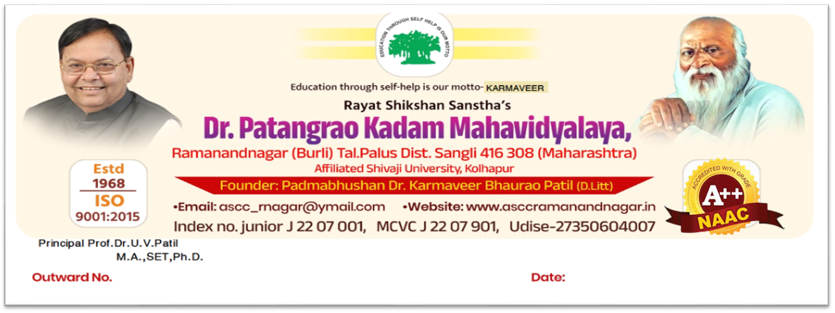
Dept. of Political Science
Time Table – 2026 -2027
Sr. No | Time | Mon |  | Tue |  | Wed |  | Thu |  | Fri |  | Sat
1 | 7.30 to 8.20 | BA – I  SCP |  | BA – I  SCP
 |  | BA – II  SJY(Minor) |  | BA – II  SJY(Minor) |  | BA – II  SJY(Minor) |  | BA – II  SJY(Minor) |  | BA – II  RMP(Major) |  | BA – II  RMP(Major)
 |  | BAIII(Major)SSK |  | BAIII(Major)SSK |  | BAIII(Major) SCP |  | BAIII(Major)SSK |  | BA III(Minor)SSK |  | BA III(Minor)SSK
2 | 8.20 to 9.10 | BA – I  SEC  RMP |  | BA – I  SEC  RMP |  | BA - I  SCP |  | BA - I  SCP
 |  | BA – II  SCP (Major |  | BA – II  SCP(Major) |  | BA – II  RMP(Major) |  | BA – II  RMP(Major) |  | BA – II  SCP (Major) |  | BA – II  SCP (Major)
 |  | BA –III  SJY (Major) |  | BA –III  SJY (Major) |  | BA –III  SSK(Minor) |  | BA –III  SSK(Minor) |  | BA –III  RMP(ME) |  | BA –III  RMP (ME)
3 | 9.10 to 10.00 | BA – II  SEC  SCP |  | BA – II  SEC  SCP |  | BA –II  VSC RMP |  | BA –II  VSC RMP |  | BA – II  IKS SJY |  | BA – II  IKS SJY
 |  | BA –III  RMP (ME |  | BA –III  RMP (ME |  | BA –III  SJY(Major) |  | BA –III  SJY(Major) |  | BA –III  SSK(Major) |  | BA –III  SSK(Major)
 | 10.00 to 10.10 | Short Recess
4 | 10.10 to 11.00 | B.Sc III OE SSK | B.Sc III OE SSK |  |  |  |  |  |  |  | B Sc – I  OE SJY
 |  |  |  |  |  |  |  |  |  |  | B.Sc II OE SSK
I
5 | 11-00 to 11.50 |  |  |  |  |  |  |  |  |  | B Sc – I  OE SJY
 |  |  |  |  |  |  |  |  |  |  | B.Sc II OE SCP
6 | 11-50 to 12.40
7 | 12-40 to 1.30

Sr No | Name | BAI | BAII | BAIII | B.Sc I | B.Sc II | B.Sc III | Total
01 | Dr.Patil S.C. | 04 | 06 | 01 | ----------- | 01 | ---------- | 12
02 | Mr.Kokare S.S. | ---------- | ---------- | 09 | ---------- | 01 | 02 | 12
03 | Mr. Pawar R.M. | 02 | 06 | 04 | ---------- | -------- | ---------- | 12
04 | Dr.Yadav S.J. | ---------- | 06 | 04 | 02 | -------- | ---------- | 12
 |  |  |  |  |  |  | Total | 48

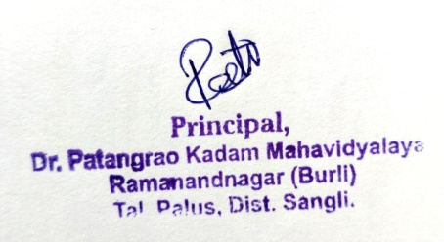
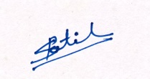

Dr. S. C. Patil
HOD
Department of Political Science

