Rayat shikshan sanstha's
Dr.Patangrao Kadam Mahavidyalay Ramanandnagar(Burli)
Result Analysis Committee
Departmental Information
2025-2026
Department of Political science

Total Number of Students | 10
Total Number of appeared Students | 08
Total Number of Pass Students | 06
Total Number of Students in Distinction | -
Total Number of Students in First Class | 01
Total Number of Students in Second Class | 05
Total Number of Students in Pass Class | 00
Total Number of Students in Fail Class | 02
Total Number of Pass Students | 06
Percentage of Passing | 75 %
Name of 1st Ranker | DHAINJE NISHANT NIVAS
Total Marks of 1st Ranker(With English Marks) | 216 (62.57%)
Total Marks of Ist yr+IInd yr+III rd yr=Total of1st Ranker | 1724+10 (78.82%)
Name of 2nd Ranker | PATIL SAGAR SURESH
Total Marks of 2nd Ranker(With English Marks) | 209 (58.71%)
Total Marks of Ist yr+IInd yr+III rd yr=Total of 2nd Ranker | 1520+10 (69.55%)
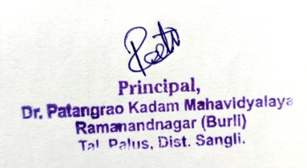


Chairman
Result Analysis Committee

Rayat shikshan sanstha's
Dr.Patangrao Kadam Mahavidyalay Ramanandnagar(Burli)
Department of Politcal science
Category wise Result - 2025 - 2026
Roll No. | Student Name | Category | M/F |  | Sem V |  |  |  |  |  |  |  |  | Sem VI |  |  |  |  |  |  | Percentage %
 |  |  |  | VII | VIII | IX | X | XI | SEC | Total | Grand Total | XII | XIII |  | XIV | XV | XVI | SEC | Total | Grand Total | Percentage %
 |  |  |  | Out of 50 | Out of 50 | Out of 50 | Out of 50 | Out of 50 |  | Out of 250 | With English Marks | Out of 50 | Out of 50 |  | Out of 50 | Out of 50 | Out of 50 |  | Out of 250 | With English Marks | Percentage %
1 | DHAINJE NISHANT NIVAS | SC | M | 31 | 25 | 30 | 29 | 31 | 40 | 204 | 222 | 30 | 35 |  | 28 | 29 | 37 | 34 | 193 | 216 | 62.57
2 | GHORPADE SANIKA SUNIL | OPEN | F | 29 | 26 | 34 | 29 | 24 | - | 142 | 171 | 28 | 30 |  | 24 | 33 | 38 | - | 153 | 176 | 57.83
3 | JADHAV SAHIL KIRAN | OPEN | M | 27 | 27 | 24 | 25 | 24 | 40 | 167 | 190 | 23 | 26 |  | 16 | 28 | 29 | 32 | 154 | 172 | 51.71
4 | KORE PRATHAMESH ASHOK | OBC | M | AB | AB | AB | AB | AB | AB | AB | - | AB | AB |  | AB | AB | AB | AB | AB | - | -
5 | MATKARI RAMCHANDRA HANMANT | NT(C) | M | 22 | 24 | 23 | 30 | 30 | 38 | 167 | 182 | 25 | 27 |  | 24 | 24 | 29 | 38 | 167 | 191 | 53.28
6 | PATHAN SAMIR GAFAR | OBC | M | 24 | 30 | 23 | 26 | 24 | 40 | 167 | 190 | 24 | 27 |  | 14 | 24 | 27 | 36 | 152 | 171 | 51.57
7 | PATIL SAGAR SURESH | SBC | M | 28 | 25 | 32 | 26 | 28 | 40 | 179 | 202 | 33 | 32 |  | 27 | 28 | 28 | 38 | 186 | 209 | 58.71
8 | SALUNKHE MUKTABAI HARSHAL | ST | F | 31 | 27 | 31 | 28 | 31 | 26 | 174 | 190 | 27 | 24 |  | 24 | 27 | 28 | 40 | 170 | 193 | 54.71
9 | THORAT DIPAK PANDURANG | OPEN | M | 24 | 22 | 22 | 24 | 24 | 40 | 156 | 179 | 24 | 26 |  | 24 | 25 | 28 | 36 | 163 | 186 | 52.14
10 | YADAV TEJAS ANANDA | OPEN | M | 14 | 20 | 24 | 24 | 22 | 38 | 142 | 142 | AB | AB |  | AB | AB | AB | AB | - | - | 47.33
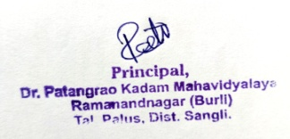


Chairman
Result Analysis Committee

Rayat shikshan sanstha's
Dr.Patangrao Kadam Mahavidyalay Ramanandnagar(Burli)
Result Analysis Committee
Department of political science
2025-26
Table-1 : Total Number of Students Appeared in the Final Year (*T=Transgender)
Category | General Category |  |  |  | EWS Category |  |  |  | Sheduled Caste(SC) |  |  |  | Sheduled Tribe(ST) |  |  |  | Other Backward Class(OBC) |  |  |  | Total
 | M | F | T | Total | M | F | T | Total | M | F | T | Total | M | F | T | Total | M | F | T | Total | M | F | T | Total
 | 02 | 01 | - | -03 | - | - | - | - | 01 | - | - | 01 | - | 01 | - | 01 | 03 | - | - | -03 | 06 | 02 | - | 08

Table-2 : Total Number of Students Passed/Awarded Degree in Final Year
Category | General Category |  |  |  | EWS Category |  |  |  | Sheduled Caste(SC) |  |  |  | Sheduled Tribe(ST) |  |  |  | Other Backward Class(OBC) |  |  |  | Total
 | M | F | T | Total | M | F | T | Total | M | F | T | Total | M | F | T | Total | M | F | T | Total | M | F | T | Total
 | 02 | 01 | - | 03 | - | - | - | - | 01 | - | - | 01 | - | 01 | - | 01 | 03 | - | - | 03 | 06 | 02 | - | 08

Table-3 : Total Number of Students Passed with 60% and above in Final Year
Category | General Category |  |  |  | EWS Category |  |  |  | Sheduled Caste(SC) |  |  |  | Sheduled Tribe(ST) |  |  |  | Other Backward Class(OBC) |  |  |  | Total
 | M | F | T | Total | M | F | T | Total | M | F | T | Total | M | F | T | Total | M | F | T | Total | M | F | T | Total
 | - | - | - | - | - | - | - | - | 1 | - | - | 01 | - | - | - | - | - | - | - | - | 01 | - | - | 01
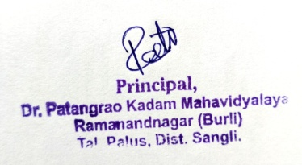

Chairman
Result Analysis Committee

