Rayat Shikshan Sanstha’s
Dr. Patangrao Kadam Mahavidyalaya, Ramanandnagar( Burli)
Tal-Palus, Dist.-Sangli

Department of Zoology

Study Tour : 7th November,2025
‘Chitale Dairy- Bhilawadi’

Following Students of B.Sc.II participated in this study tour.


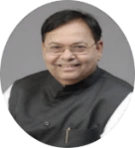
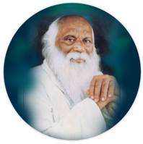

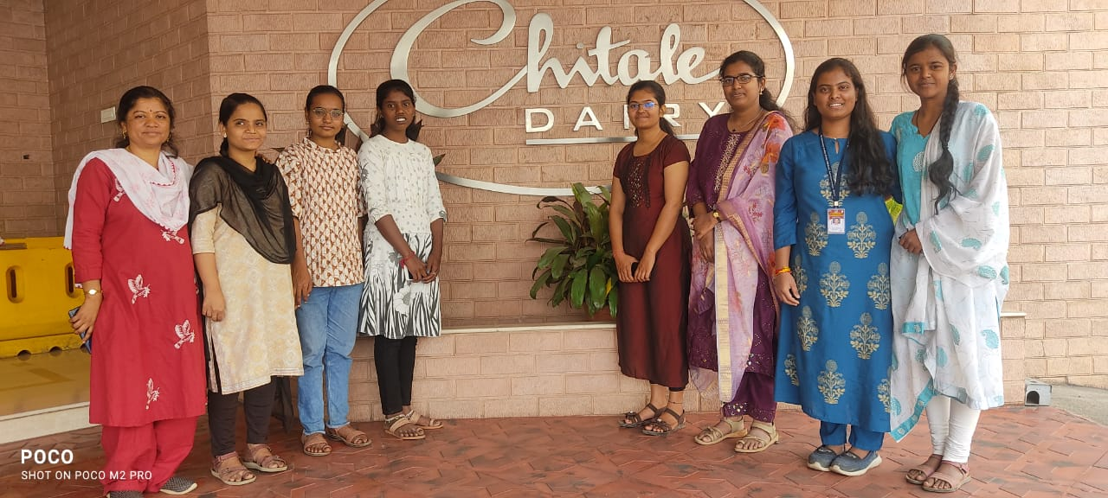

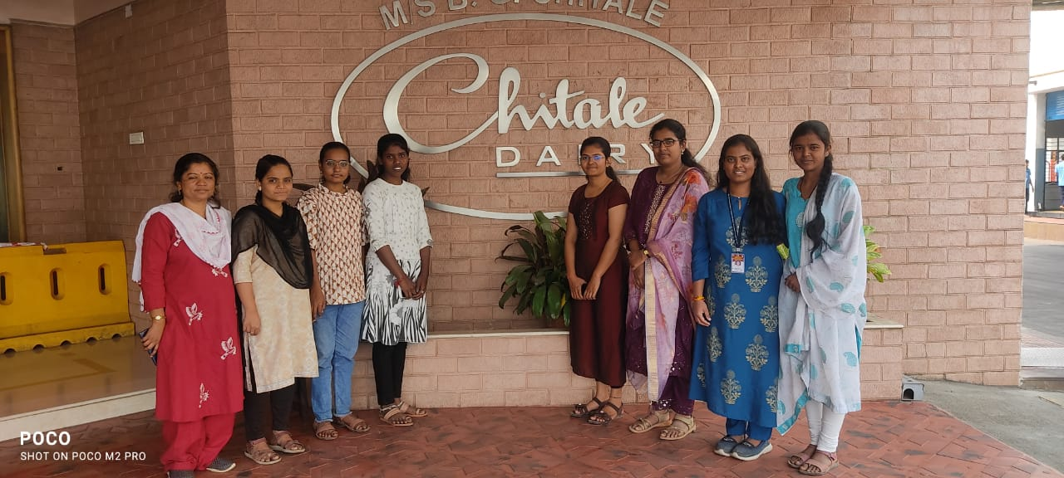

Chitale Dairy Visit: Dr. Mhaske M. C. and B.Sc.-II Students

